CYCLE CLUB SUDBURY

‘FALLING LEAVES’ HILLCLIMB.

Incorporating East District Cycle Association Hill Climb Championship
and C.C. Sudbury Hill Climb Championship
SUNDAY 16th October 2016
Promoted for and on behalf of Cycling Time Trials under their Rules and Regulations

Event Secretary: David Fenn. 10, St Marys Close, Chilton, Sudbury, Suffolk. CO10 0PN.
Tel. no. 01787 374284. Mobile: 07884487846. Email: dr.fenn@tiscali.co.uk

Timekeepers: Linda Pillet, Colin Kindred, Robin Weaver and Brian Webber

This event takes place on Watson’s Hill, Semer (from the B1115 Hadleigh to Bildeston road at Semer Bridge up towards the Hollowtrees farm shop). See C.C. Sudbury web-site for details.
http://www.cycleclubsudbury.com/events/hillclimb

Course details: BHC/1. Start: at edge of driveway approx. 5 yards from electricity pole 5 at foot of hill. Finish: at gap in hedge just over brow of hill, on left. Distance: 500 yards.
We have arranged a road closure for this event. The course will also be swept.

First rider off: 11:01am.

Headquarters: Semer Village Hall, IP7 6JG, on the B1115 between Hadleigh and Bildeston just after the junction with the A1141 travelling in the direction towards Bildeston. https://maps.google.co.uk/?q=52.074813,0.924973

Refreshments will be available on the day, both before and after the event, donations invited, with profits going to East Anglia’s Children’s Hospices.

Numbers: will be at the HQ and not at the start. Sign on here and exchange your number for a drink when you finish.

Safety: In the interests of safety, Cycling Time Trials and the event promoters strongly advise you to wear a Hard Shell Helmet that meets international accepted safety standards.
All competitors under the age of 18 years and /or juniors must wear a properly affixed helmet that should conform to the recognized Standard such as Shell B95.

C.T.T. East District local regulations: U-Turns will not be permitted on the course or roads adjacent to start and finish areas while the race is in progress. Note any breaking of this regulation in the first case may mean disqualification from the event; further cases will be referred to the District council. Definition: a U-turn is defined as a 180 degree turn completed within the highway whilst astride the machine (it is recommended that the rider should dismount check the road is clear in both directions, then with machine walk across the road.)
Warming up: no warming up along the course by competitors once an event has started.
Turbo trainers: the use of turbo trainers is banned at all events with am. start times.
The East District Committee recommends that competitors should fit a rear LED light to enhance visibility to other road users. Please keep your head up at all times, head down riding can kill. Have a safe and enjoyable ride.
Once the event is in progress non-competing cyclists will not be allowed to ride their bikes on the course. Any non-competing cyclists seen riding their bikes on the hill will be asked by a marshall to get off and walk. Please respect the competing riders.

Car parking: will be available in the car park adjacent to Semer village hall, plus there will be parking in the meadow at the foot of Watson's Hill (this will be sign posted and marshalled on the day). This will be just yards from the start line. See map below.
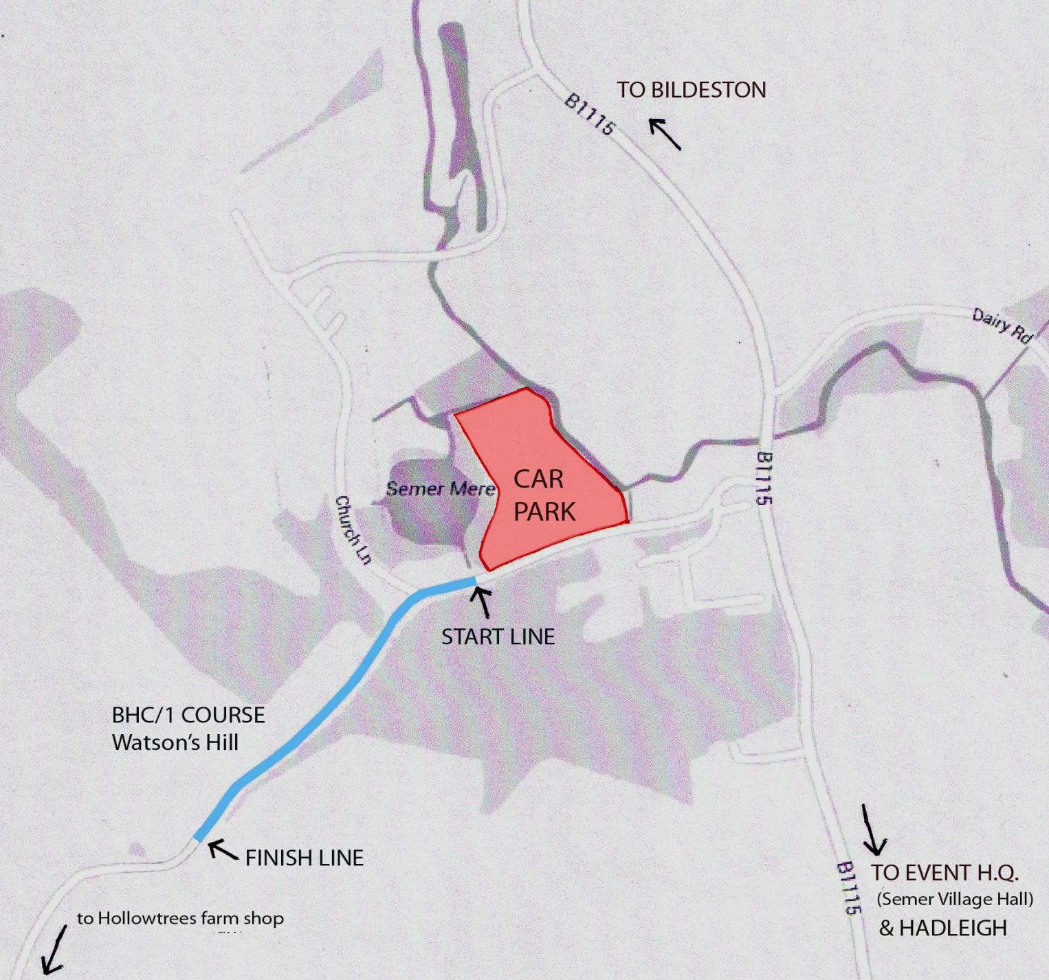
No car parking on the main road or near the start or finish.

Trophies:
This event incorporates the East District Hill Climb Championships. The prestigious East District trophies will be presented after the event at HQ to the fastest individual rider and fastest team of three riders from the East District. There are also trophies for the fastest overall team (not necessarily from the East District) and the fastest Lady (Boxford BC Trophy) so please stay after the event to collect your trophies. The event also incorporates the C.C. Sudbury Hill Climb Championships the trophies & medals for which will be presented at the annual Club Dinner in November.

Prize money: Many thanks to local bike shop Lifecycle UK, Bildeston, for generously sponsoring these prizes.

Men Women  1st = £40 1st = £40  2nd= £25 2nd= £25  3rd= £20 3rd= £20  4th= £15 4th= £15  5th = £10 | Phone: 01449 744467  Email: mat@lifecycleuk.com  Website: http://www.lifecycleuk.com  Address: 108 High Street, Bildeston, Suffolk, IP7 7EB

Fastest Junior & Juvenile (male) = £15
Fastest Juvenile (female) = £15

Team (of 3 riders) prizes 1st = £15 per rider, 2nd = £10 per rider, 3rd = £5 per rider.

The above-mentioned prizes will not be presented at the event. One team prize per club and one prize per rider except for team (& course record) prizes

Course record prizes:
£75 for the person who sets the new overall course record
(Currently 43.4 seconds -Tom Stephenson- Colchester Rovers C.C. - 2011)

£75 for the woman who sets the new women's course record
(Currently 54.7 seconds- Samantha Segger, Boxford Bike Club. - 2015)

Only one rider will be eligible for each particular course record prize. These prizes will be presented on the day- so please stay around to collect your money if you break the record.

Many thanks to local insurance company, Robins Row of Long Melford for generously sponsoring the course record prizes.

