FOR SALE
DOLAN SCALA TIME TRIAL BIKE – MEDIUM.
- Campag Bullet 700C x 80 mm deep carbon wheels
with Aluminium breaking surface.
- Campag Veloce 50 / 34 Chainset.
- Campag Veloce front and rear changers.
- Campag bar end gear levers.
- 10 speed close ratio Cassette.
- TRP integrated front and rear brakes.
- Fizik Saddle.
- Zipp TT bars with Deda Stem and Aero extensions.
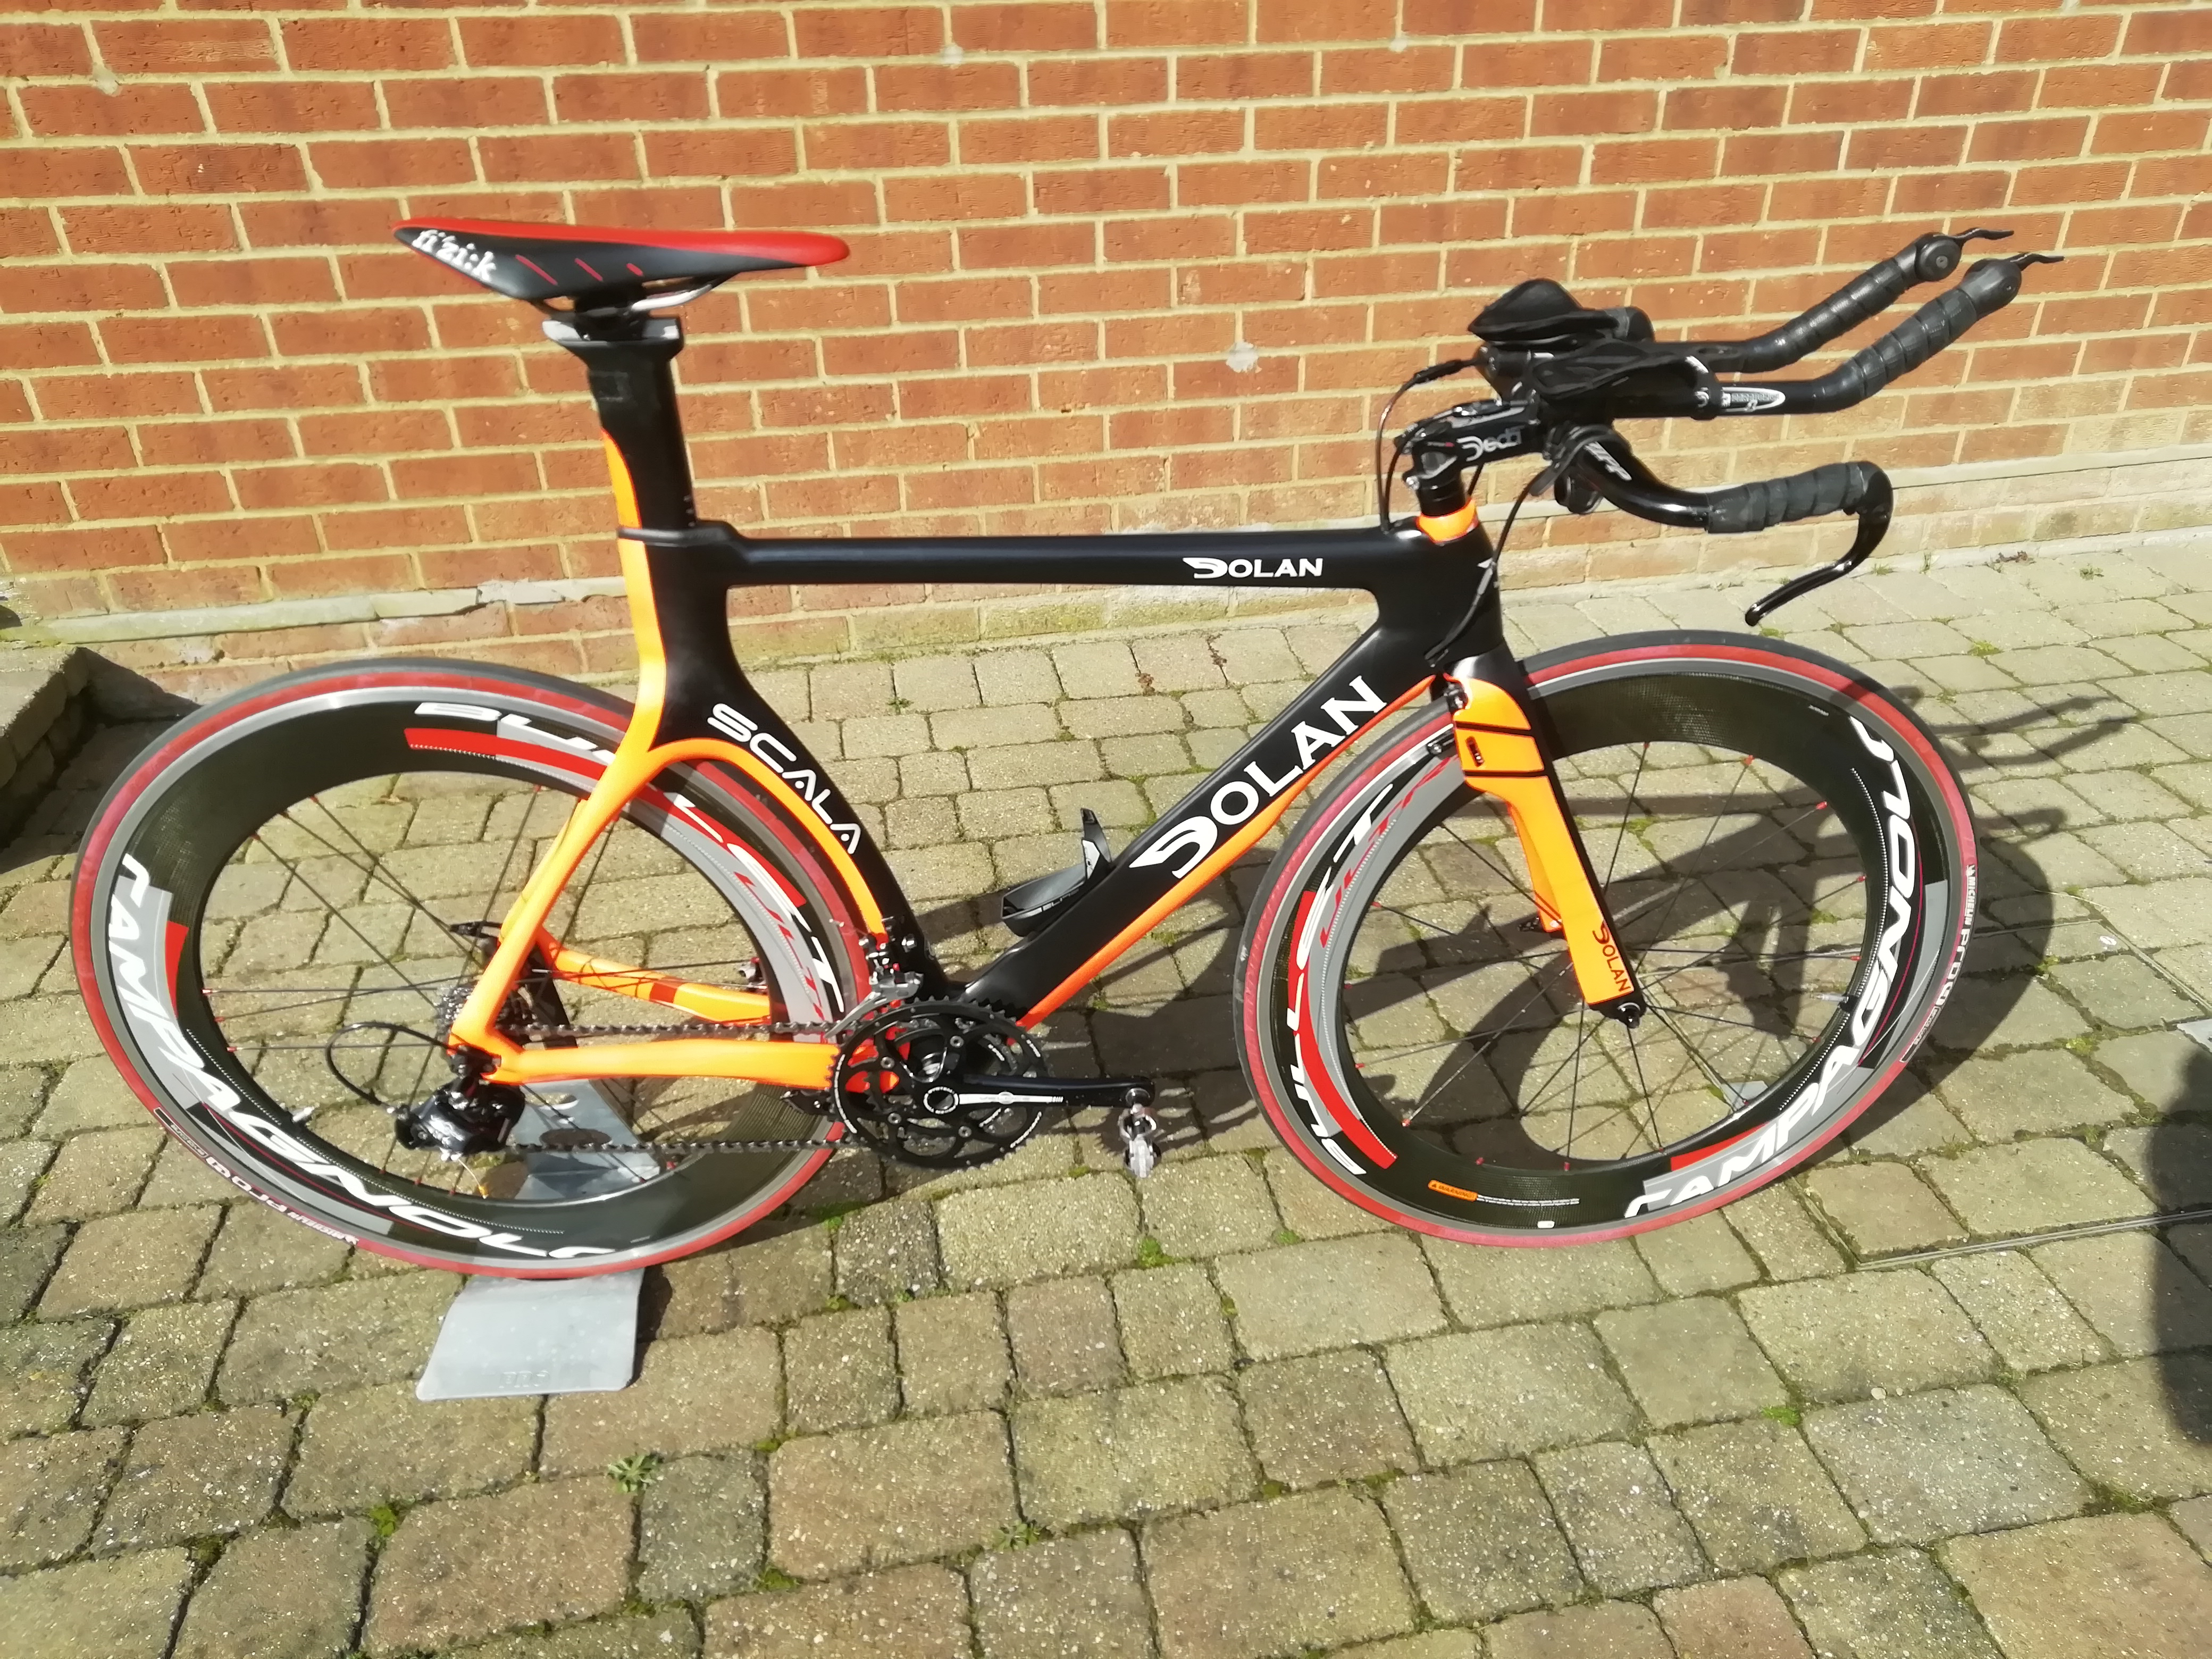
Price; Would like to get £1,250-00 but will consider offers
Contact; David Fenn
Tel; 01787374284. Mobile; 07884487846.
Email; dr.fenn@tiscali.co.uk

