FOR SALE
54 cm Raleigh Road Bike.
- Frame, Reynolds 853.
- Campag Centaur 50/34 chainset.
- Campag Xenon rear changer.
- Campag Veloce front changer.
- Campag Xenon shifters
- Campag Cenataur brakes.
- Wheels, Campag hubs with Mavic CXP30 rims.
- 10 speed cassette.

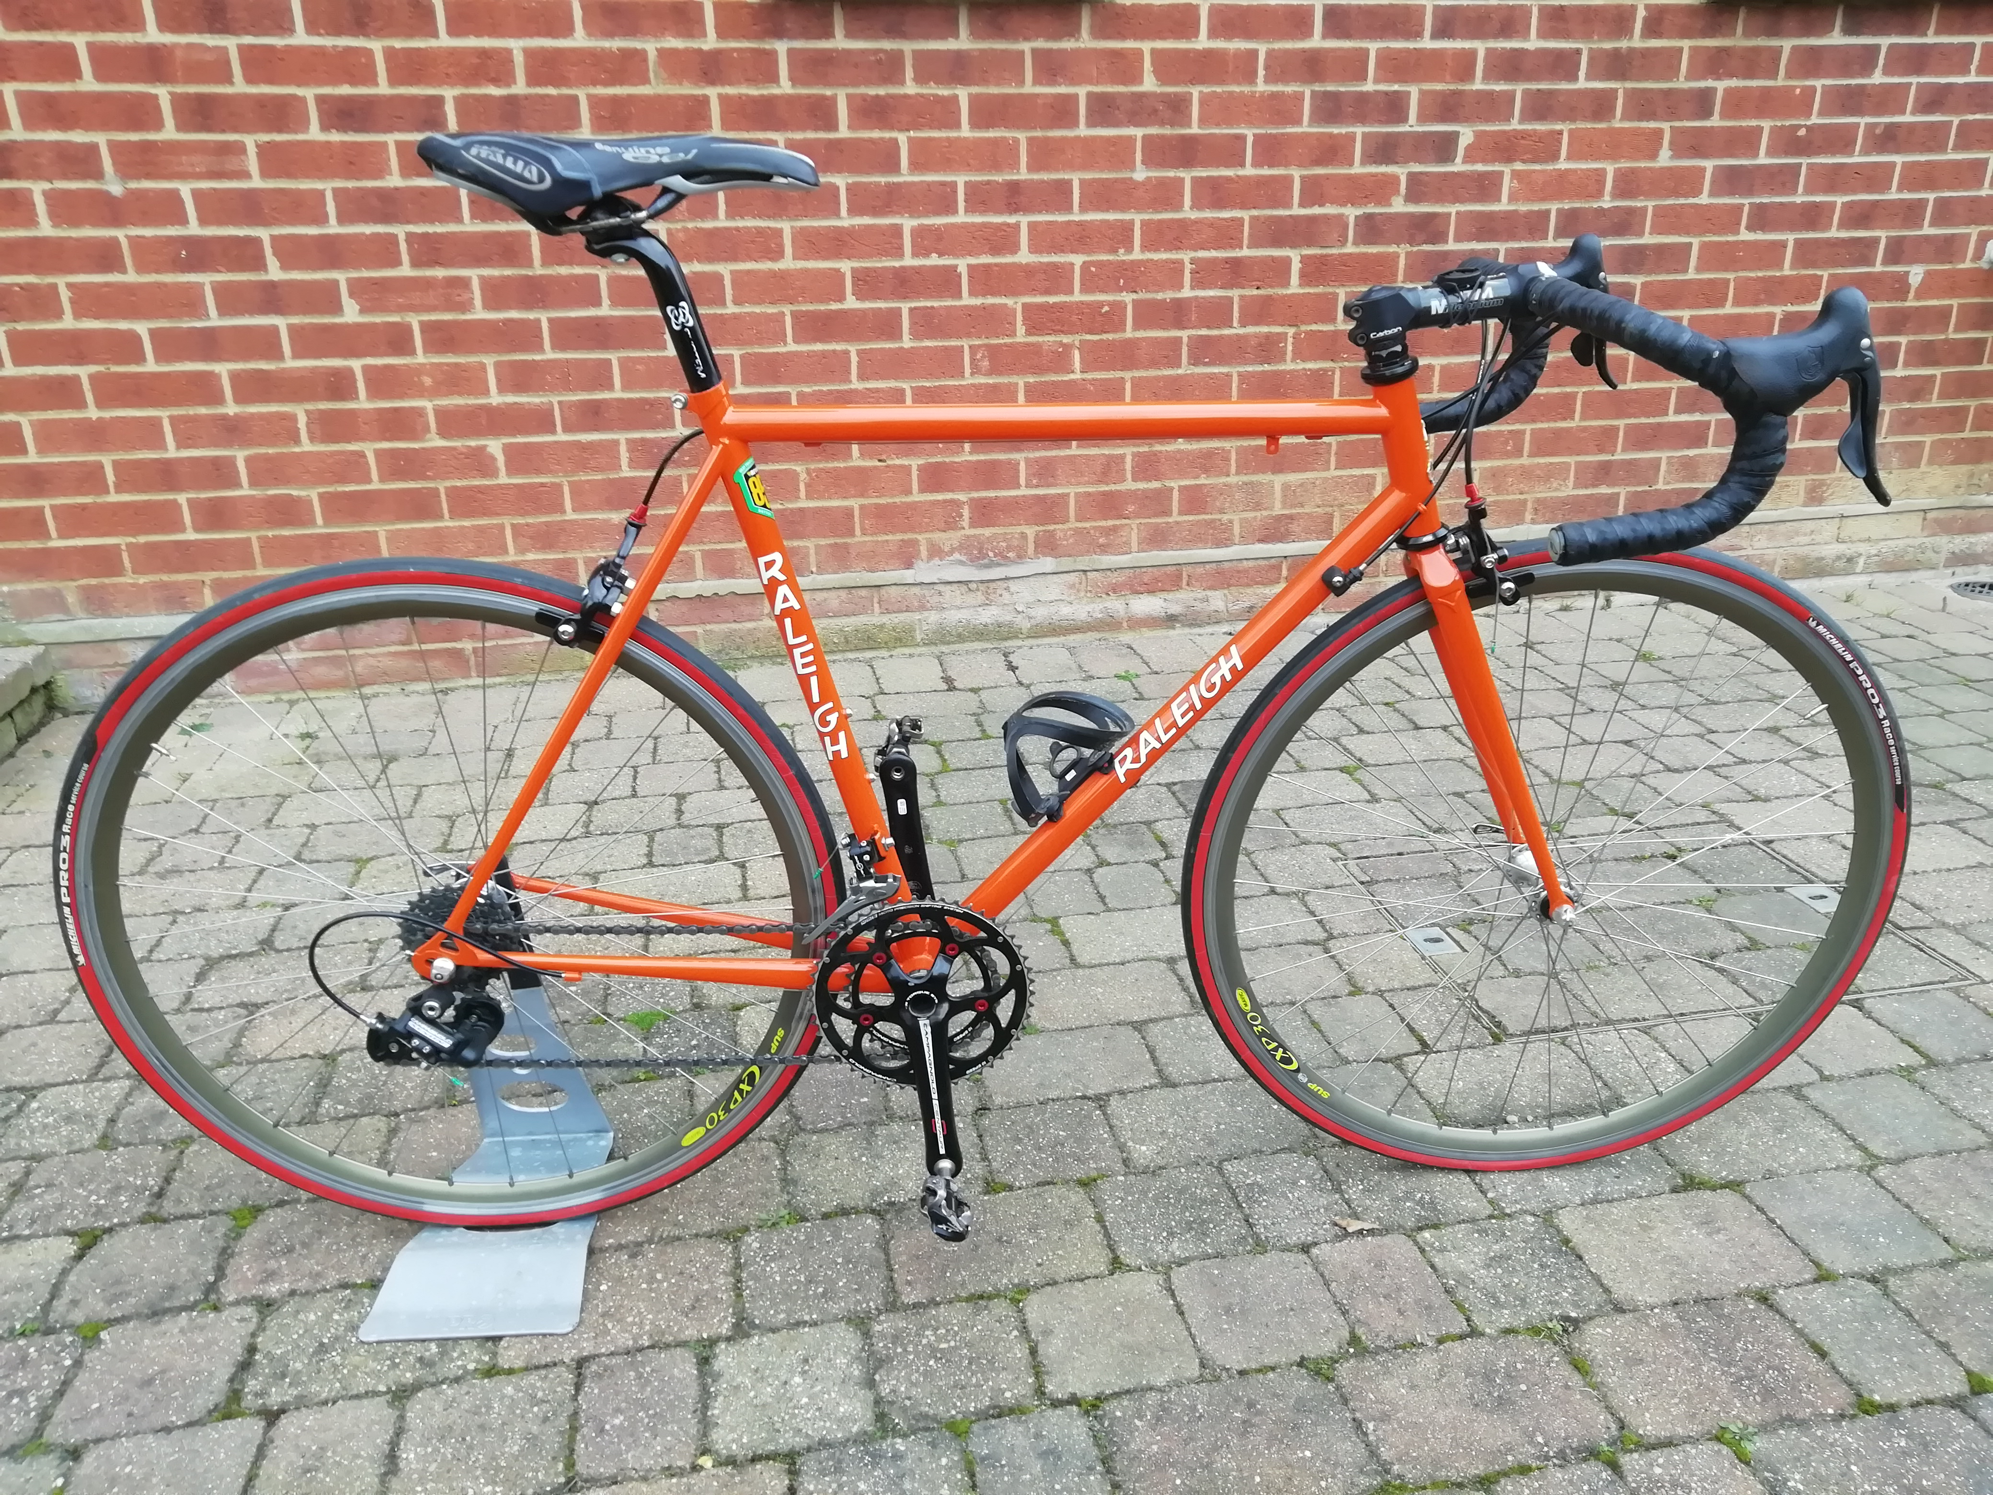
Price; Would like to get £500 but will consider offers.
Contact; David Fenn.
Tel; 01787374284 Mobile; 07884487846
Email; dr.fenn@tiscali.co.uk

